Apart-maint: Software Design Specification

The Software Design Specification (SDS) sections provide you with guidelines related to the structure and the contents of SDS document. The Software Design Specification document includes at least these sections.

For the project, your team may have good reasons for wanting to deviate from this proposed outline. If a section is not applicable in your case, do not delete it; instead, give the topic heading and write "Not applicable".

You will note that there is some overlap in the content between different documents (i.e. the User Requirements Specification Document and the Software Design Specification Document.) This redundancy allows each document to stand on its own.

The Software Design Specification Outline
1. Introduction

1.1 Purpose of this document
The purpose of this document is to describe the implementation of the web application “Apartmaint”. The Apartmaint software is used to automate the process of management in large apartment/society.

1.2 Scope of the development project
This Product is intended for the purpose of automation of the apartment/society/community and its working. The product will be used by home-owners and authorities to connect to each other on a virtual platform to save time and increase the efficiency of the current existing system which is manual in nature.

1.3 Definitions, acronyms, and abbreviations

Definition, Acronyms and Abbreviations | Description
Module | Each of a set of standardized parts or independent units that can be used to construct a more complex structure, such as an item of furniture or a building.
System | a set of things working together as parts of a mechanism or an interconnecting network
Database | a structured set of data held in a computer, especially one that is accessible in various ways.
Php | Pre Hypertext Processor;PHP is a script language and interpreter that is freely available and used primarily on Linux Web servers. PHP, originally derived from Personal Home Page Tools
Framework | PHP framework is a library that makes the life of site developer easier by for example hiding some complexities of HTTP protocol or by adding some useful functions
Codeigniter | CodeIgniter is an open-source software rapid development web framework, for use in building dynamic web sites with PHP.
Library | Codeigniter libraries means classes which located in libraries directory. ... It's easy to create new/ custom library , replace native or extend native library in codeigniter

1.4 References
This section will include technical books and documents related to design
Issues. Be certain that the references you give are complete and in
The appropriate format.

1.5 Overview of document
The Software Design Document is divided into 7 sections with various subsections. The sections of the Software Design Document are:

1. Introduction
2. System Architecture description
3. Detailed Description of Components
4. Reuse and relationship to other products
5. Design Decisions and Tradeoff
6. Pseudocode
7. Appendices

2. System architecture description

2.1 Overview of modules / components

2.1.1 Description of Problem
Traditional method for the management of apartment associated issues and activities is often slow, require a lot of time to address these issues and activities. This is in fact creates a lot of paper work and manual labor from both side of interface.

2.1.2 Technologies Used
The Apartmaint software will communicate to the end user through personal computer as web applications are designed for it. Web application is built using Php(pre hypertext processor) technologies which supports MVC structure.

The product is cross-platform and supports in all operating system which has basic internet browser such as Google chrome, Mozilla Firefox, Safari, Opera, Maxathon etc.

2.2 Structure and relationships
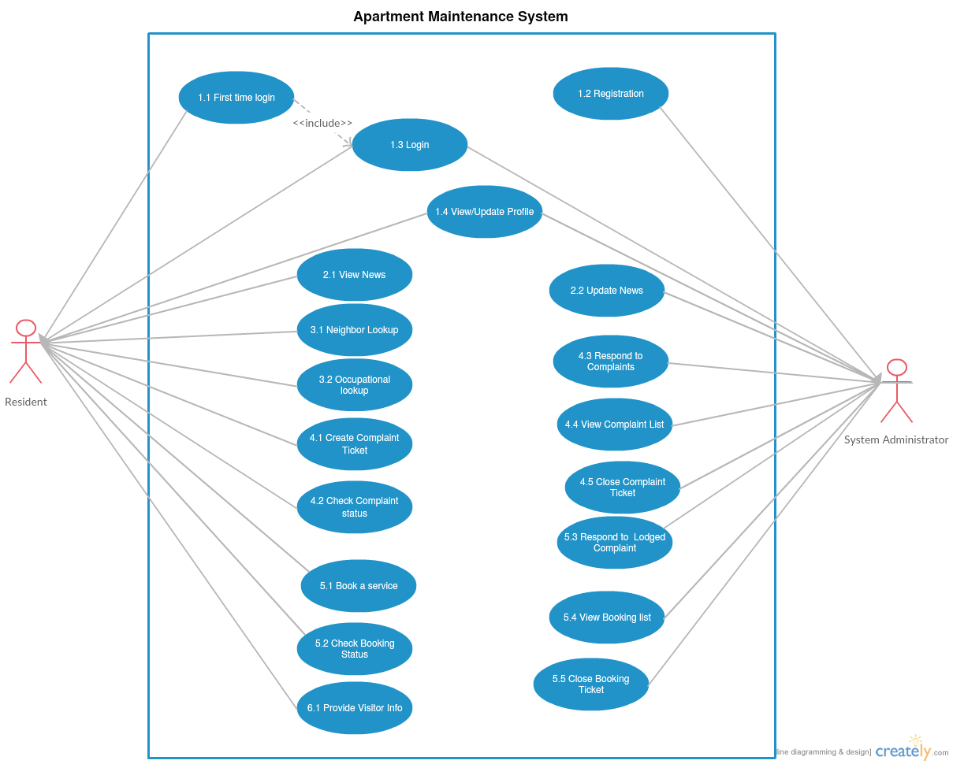

Resident Interface: The interface for constructing, viewing and editing their level modules.
System Administrator: The interface for viewing and editing all level of modules responses from resident interface.
Login: Simple login module to uniquely identify Resident/System Administrator.
Register: Simple register module to give Unique credentials to Residents, only System administrator interface can access.
Service: Simple module to maintain the service entity of the system.
Complaint: Simple module to maintain the complaint entity of the system.
Neighbor Lookup: Simple module to search for details of neighbor.
News System: Simple module to maintain the news entity of the system.

2.3 User interface issues
This section will present the main principles of the product's user interface. Use the personas defined in section 2.1 of your SRS to make specific examples. This section should not touch on technical details. You may want to include sketches and specific text messages.

3. Detailed description of components

3.1 Component template description
Following are the structures and relationships between various modules:
3.2.1 Class Diagram:

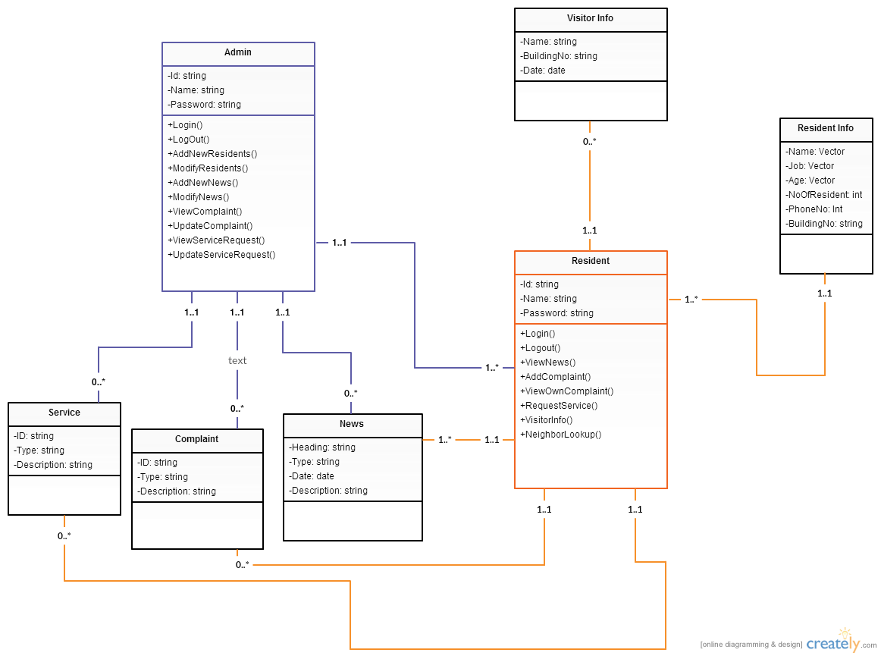
The following diagram depicts the UML Model for the Apartment Management Interface.

Description of Class Diagram Components

7.1. Admin

7.1.1 Attributes

Name | Type | Description
Id | String | The user id of the administrator
Name | String | The name of the administrator
Password | String | The password of the administrator

7.1.2 Methods

Void login()
Input: | The user provides the username and password so that the credentials can be checked and authenticated
Output: | The user is successfully logged in
Description: | It is an authentication feature to determine the user profile.

Void Logout()
Input:
Output: | The user is successfully logged out
Description: | This method allows the user to logout

Int AddNewResidents()
Input: | Resident information
Output: | Successfully adds new resident.
Description: | This allows us to add new residents

Int ModifyResidents(Resident R)
Input: | Resident information
Output: | Successfully modifies any credentials of the residents.
Description: | Allows to modify the details of the resident

Int AddNewNews()
Input: | New news to be added
Output: | New news updated successfully
Description: | The news alert feature to add the current news of the apartment

Int ModifyNews(News N)
Input: | The news to be modified
Output: | The news modified/updated successfully
Description: | The news modification that allows admin to make changes/modification to the current news(if any)

Int ViewComplaint(Complaint C)
Input: | The complaint information.
Output: | All complaint request.
Description: | Allows the user to view the resident’s complaints.

Int UpdateComplaint(Complaint C)
Input: | The complaint status to be updated
Output: | The complaint request is updated successfully.
Description: | Allows the user to update the status of the complaint.

Int ViewServiceRequest(Service S)
Input: | The service request information.
Output: | All service request.
Description: | Allows the user to view the service that has been made.

Int UpdateServiceRequest(Service S)
Input: | The service status to be updated.
Output: | The service request is updated successfully.
Description: | Allows the user to update the status of the service request.

7.2 Service

Name | Type | Description
Id | String | The service ticket number
Type | String | Books type of service like electrician ,plumber ,carpenter etc.
Description | String | Description in detail about the service needed.

7.3 Complaint

Name | Type | Description
Id | String | The complaint ticket number
Type | String | Type of complaint like housekeeping, maintenance, etc.
Description | String | Description in detail about the complaint.

7.4 News

Name | Type | Description
Heading | String | The heading of the news
Type | String | The category of news like sports ,entertainment etc.
Date | Date | The date of the news
Description | String | Description in detail about the news.

7.5 Visitor Info

Name | Type | Description
Name | String | The name of the visitor.
Building No | String | The house/building number the visitor is visiting to.
Date | Date | The date of his visit.

7.6 Resident Info

Name | Type | Description
Name | vector | Name of the resident
Job | vector | The respective job of the resident.
Age | vector | The age of the resident.
Phone no | Int | The phone number of the resident.
Building no | String | The house/building number of the resident.
No of Residents | Int | Tells the no. of residents in the house

7.7 resident

7.7.1 Attributes

Name | Type | Description
Id | String | The user id of the resident
Name | String | The name of the resident
Password | String | The password of the resident

7.7.2 Methods

Void login()
Input: | The user provides the username and password so that the credentials can be checked and authenticated
Output: | The user is successfully logged in
Description: | It is an authentication feature to determine the user profile

Void logout()
Input:
Output: | The user is successfully logged out
Description: | This method allows the user to logout

Int ViewNews(News N)
Input: | The news information
Output: | All news
Description: | Allows the user to view the news.

Int AddComplaint()
Input: | Complaint to be lodged
Output: | Complaint has been lodged successfully.
Description: | Allows the user to register a complaint

Int ViewOwnComplaint(Complaint C)
Input: | The Complaint information
Output: | All complaints of the user
Description: | Allows the resident to view lodged complaint

Int RequestService()
Input: | Service to be requested
Output: | The service has been lodged successfully
Description: | Allows the user to request a service

Int VisitorInfo()
Input: | Submission of arrival details of visitor
Output: | Successful submission of the visitor details
Description: | Allows the user to notify the security about visitor

Int Neighbour Lookup(ResidentInfo RI)
Input: | The resident house number
Output: | Details of neighbour depending upon the proximity
Description: | Allows the resident to know relevant information about their neighbour.

3.2.2 Sequence Diagrams:

Sequence of adding a new resident:

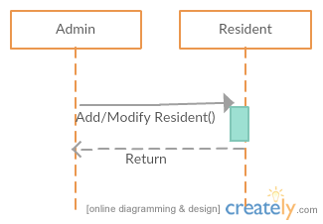

Sequence of viewing/Updating/Requesting service:

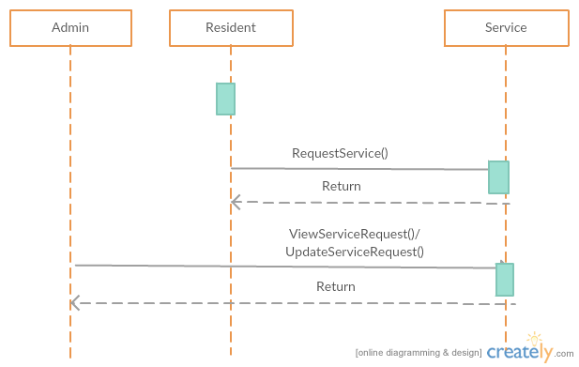

Sequence of Viewing/Updating/Requesting Complaint:

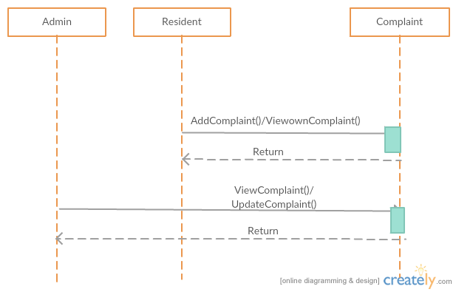

Sequence of Viewing/Adding/Modifying Complaint:

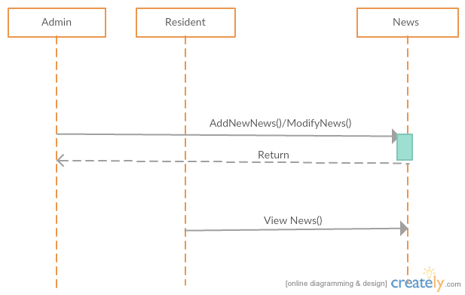

Sequence of getting Visitor Info:

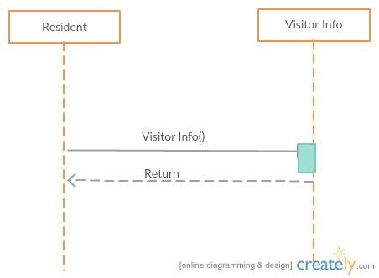

Sequence of getting Neighbor Info:

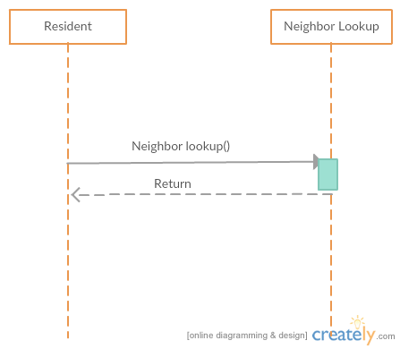

3.2.3.1 State Diagram of Login portal:

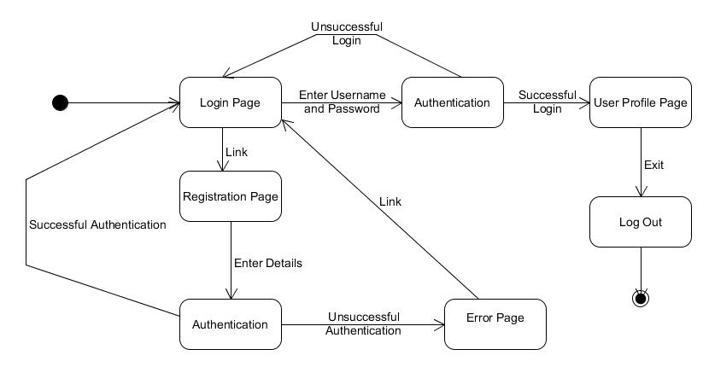

State Diagram of Neighbor lookup portal

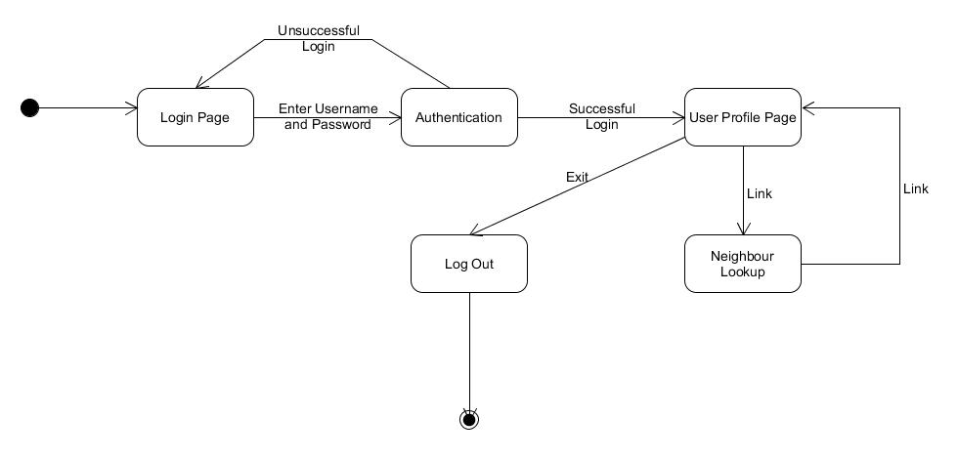

State Diagram of news from admin side

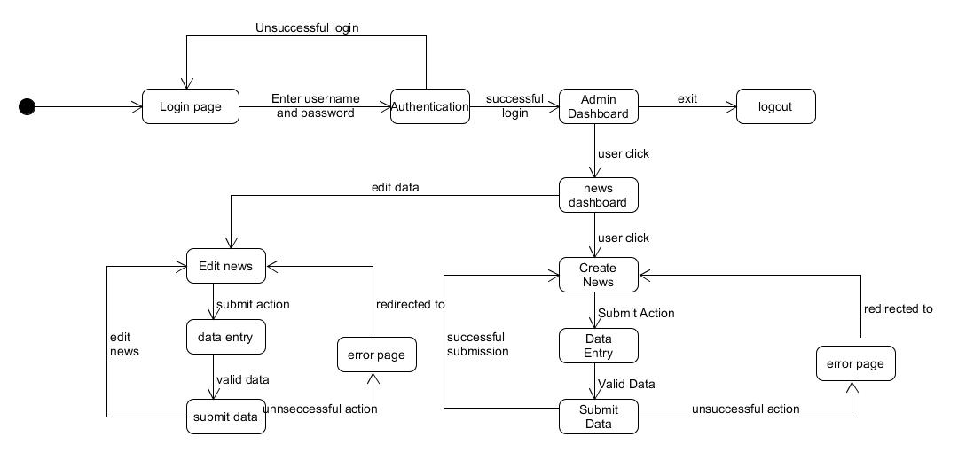

State Diagram of news portal user side

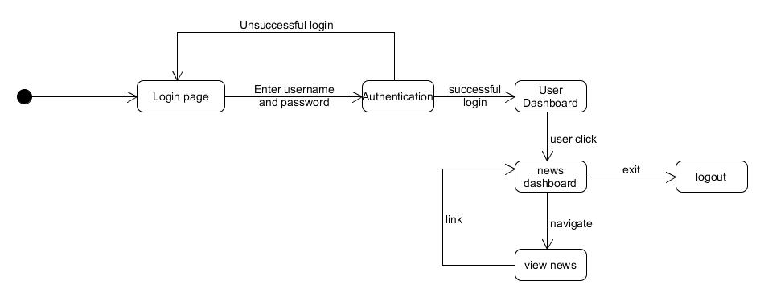

State Diagram of service from user side

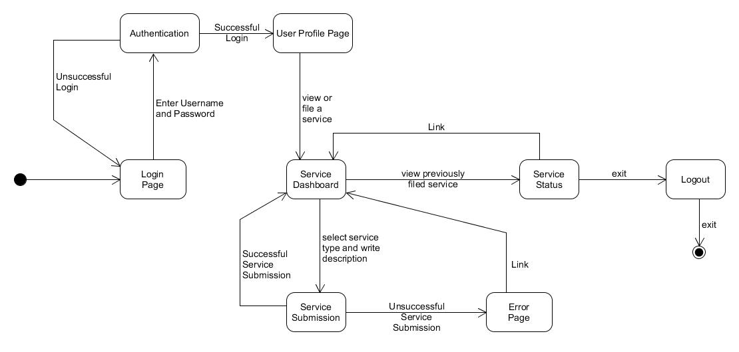

State Diagram of service from admin side

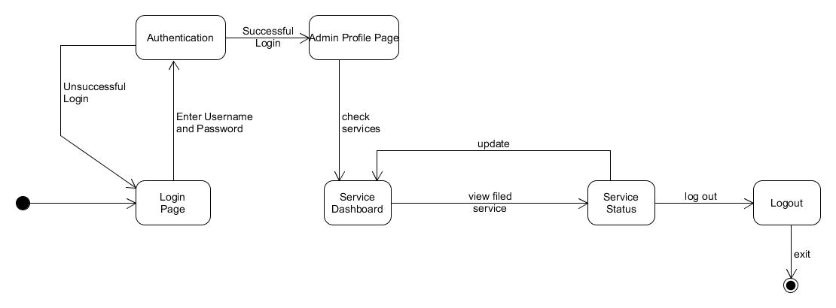
State Diagram of Complaint from admin side

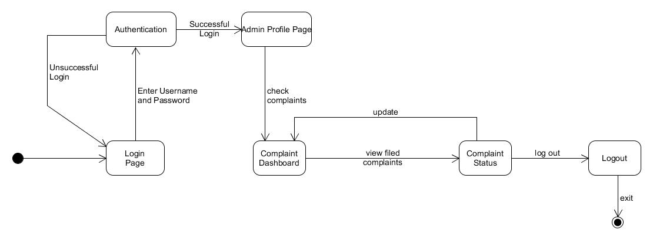

State Diagram of Complaint from user side

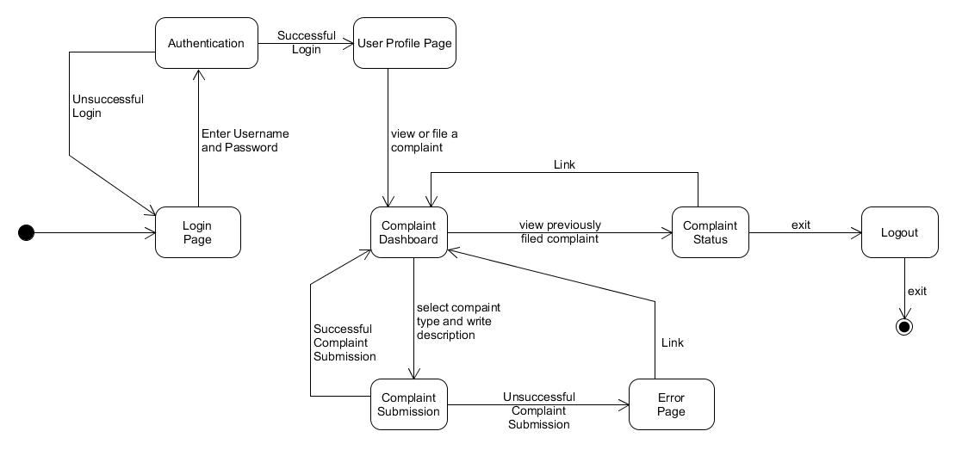

4.0 Reuse and relationships to other products

//For teams doing enhancement work, reuse is an important issue. Most enhancement work should focus on extending, rather than replacing, the design and product development from earlier semesters. For teams doing new development, reuse can also be an important strategy. In some cases, there is freeware that could be incorporated. In other cases, there are existing modules or classes that could be adapted. Another possibility is the use of special tools that produce open source results and thus permissible under the terms of this course.

This section should include the following subsections as appropriate:
- how reuse is playing a role in your product design
- how reuse is playing a role in your product implementation (and the motivation for changes)
- if you are not reusing material that is available, then give motivation for why it is being thrown out.//
Not Applicable to us

5.0 Design decisions and tradeoffs

Design tradeoffs in the software are limited not to the code or the architecture of the code but also to the physical architecture where the application reside.

Firstly, the methodology used is Iteration methodology. The reason to use this and not other methodology is that it gave us more freedom to work on the code and the test it as we had many modules. Iteration method is useful as we can make the software module by module and work on specific module at one time. This gave us time to test each module very thoroughly before moving on to the other module. This also helped us in making the modules work together as we could find the error during integration easily.

Secondly, the place where the software actually reside. We are using AsureWeb platform to host the software and all the services over there works on it. This was a useful design decision as the software would have been in a always on state as long as the AsureWeb Service was up. This was much better than hosting the service as uptime would have been in the availability of the server which could have been off due to many of the reasons such as, no power, human error etc.

Thirdly, tradeoffs made during the development processes in software were made to increase performance and increase efficiency where-ever possible. Examples of tradeoffs in the project are the framework used for development. Codeigniter is the choice in place of which we could have used other frameworks which were much faster than codeigniter. But the choice was made as codeigniter would give us gerater security which is a primary concern for most of the customers.

Use this section to motivate any decisions that will help the reader understand
the design that your team is using. This section can also capture good ideas
that were abandoned and the reasons for leaving them out of the design.

6.0 Pseudocode for components

Pseudocode for Class Methods:

Class name: Admin

Void Login ()
{
Input Id;
Input Password;
}

Void Logout ()
{ Return from Admin Portal to Login page;
}
Int AddNewResidents()
{Input no.of residents;
While (J < no. of residents)
{Input Name;
Input Job;
Input Age;
J++;
}
Input PhoneNo;
Input BuildingNo;
Connect it with a Resident Class object;
Return Status Flag of the Process;
}

int ModifyResidents(Resident R)
{Update Name of R;
Update Job of R;
Update Age of R;
Update PhoneNo of R;
Return the status flag of operation;
}

Int AddNewNews()
{Create a new News Object N;
Input Heading;
Input Type;
Input Date;
Input Description;
Return the status flag of this operation;
}

Int ModifyNews(News N)
{Update Heading of N;
Update Type of N;
Update Date of N;
Update Description of N;
Return the status flag of this operation;
}

Int ViewComplaint (Complaint C)
{View Id of C;
View Type of C;
View Description of C
Return the status flag of this operation;
}

Int UpdateComplaint(Complaint C)
{Update Description of C;
Return the status flag of the operation;
}

Int ViewServiceRequest(Service S)
{View Id of S;
View type of S;
View Description of S;
Return the status flag of this operation;
}

Int UpdateServiceRequest(Service S)
{Update Description of S;
Return the status flag of the operation;
}

Class Name: Resident

Void Login ()
{
Input Id;
Input Password;
}

Void Logout ()
{Return from Resident Portal to Login Page;
}

Int ViewNews(News N)
{View Heading of N;
View Type of N;
View Date of N;
View Description of N;
Return the status flag of this operation;
}

Int AddComplaint()
{Create a Complaint object;
Input ID;
Input Type;
Input Description;
Return the status flag of the operation;
}
Int RequestService()
{Create a Service Object;
Input Id;
Input Type;
Input Description;
Return status of the operation;
}

Int VisitorInfo()
{Create a VisitorInfo Object;
Input Name;
Input BuildingNo;
Input Date;
Return status flag of the operation;
}

Int NeighbourLookup( ResidentInfo RI)
{While(J< NoOfResidents)
{View Name of RI;
View Job of RI;
View Age of RI;
}
View PhoneNo of RI;
View BuildingNo of RI;
Return the status flag of this operation;
}

7.0 Appendices (if any)

SDS component template
The template given below suggests a reasonable structure for giving a thorough
description of each component described in Part 3 of the SDS. The specific
information depends in part on the design approach. Your team must adapt this
template to your needs and describe it in section 3.1 of your SDS.

Identification | The unique name for the component and the location of the  component in the system.
Type | A module, a subprogram, a data file, a control procedure, a class, etc
Purpose | Function and performance requirements implemented by the design component, including derived requirements. Derived requirements are not explicitly stated in the SRS, but are implied or adjunct to formally stated SDS requirements.
Function | What the component does, the transformation process, the specific inputs that are processed, the algorithms that are used, the outputs that are produced, where the data items are stored, and which data items are modified.
Subordinates | The internal structure of the component, the constituents of the component, and the functional requirements satisfied by each part.
Dependencies | How the component's function and performance relate to other  components. How this component is used by other components. The other components that use this component. Interaction details such as timing, interaction conditions (such as order of execution and data sharing), and responsibility for creation, duplication, use, storage, and elimination of components.
Interfaces | Detailed descriptions of all external and internal interfaces as well as of any mechanisms for communicating through messages, parameters, or common data areas. All error messages and error codes should be identified. All screen formats, interactive messages, and other user interface components (originally defined in the SRS) should be given here.
Resources | A complete description of all resources (hardware or software) external to the component but required to carry out its functions. Some examples are CPU execution time, memory (primary, secondary, or archival), buffers, I/O channels, plotters, printers, math libraries, hardware registers, interrupt structures, and system services.
Processing | The full description of the functions presented in the Function subsection. Pseudocode can be used to document algorithms, equations, and logic.
Data | For the data internal to the component, describes the representation method, initial values, use, semantics, and format. This information will probably be recorded in the data dictionary.

